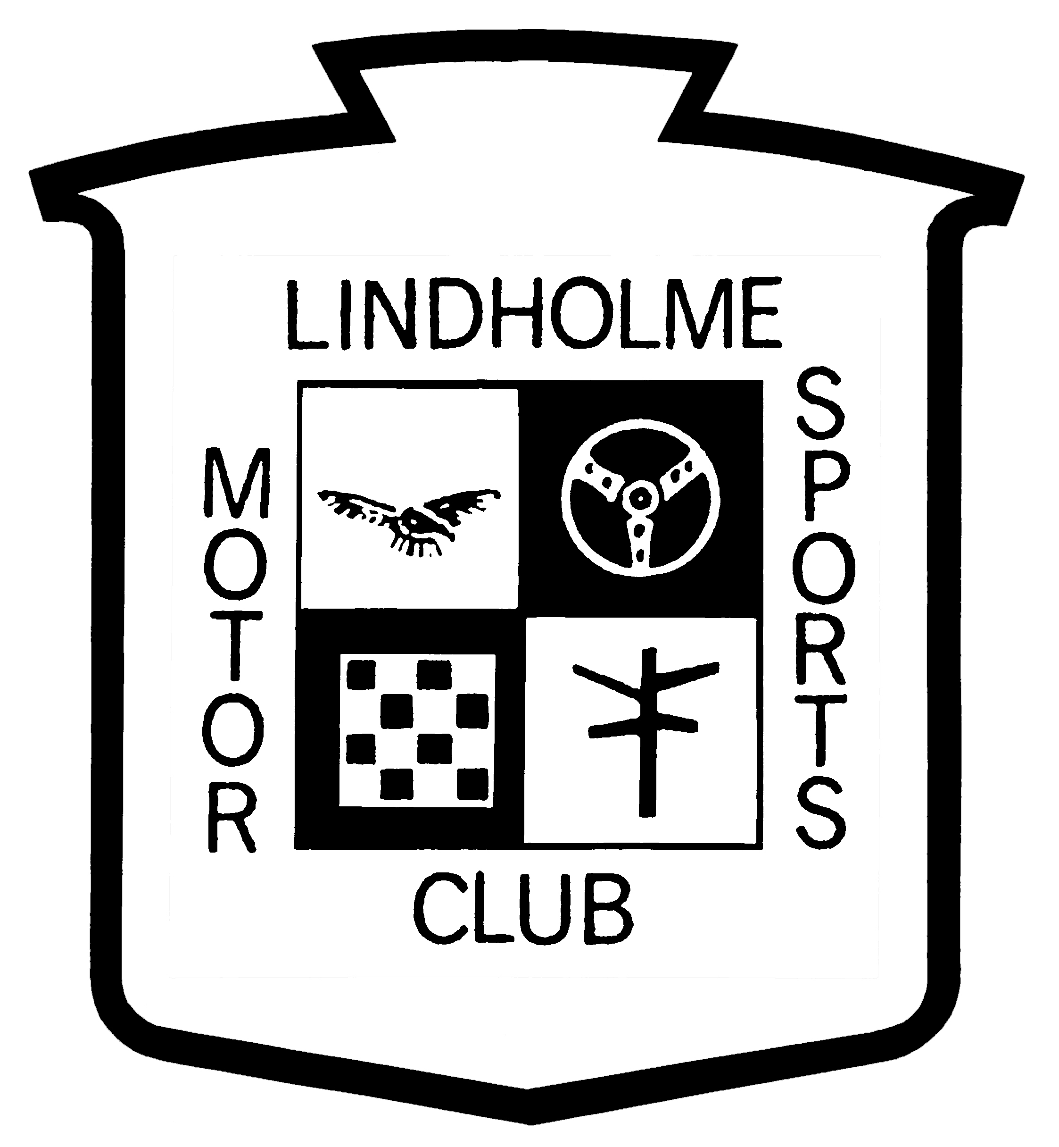

**If you have an immediate concern about a child or person, contact:**

**The Police via 999 (emergency) or 101 (non-emergency/concern)**

**Other organisations offer 24 hour helplines such as Childline (0800 1111)**

**or the NSPCC (0808 800 5000)**

Motorsport UK’s Safeguarding Officer can be contacted on 01753 765000 or via safeguarding@motorsportuk.org

***Motor Club Name/Organisation:*** Lindholme Motor Sports Club

***Safeguarding Officer Name*:** Elizabeth Janet Fowkes

***Telephone number:*** 07422 689337

***Email address:***  janfowkes204@hotmail.com

***Location:***  Vale of York Stages Rally HQ

*Motor sport should be fun. You should feel safe, enjoy the sport and everyone should be treated with respect.*

If you have a concern, make sure you report it to the Club Safeguarding Officer.

[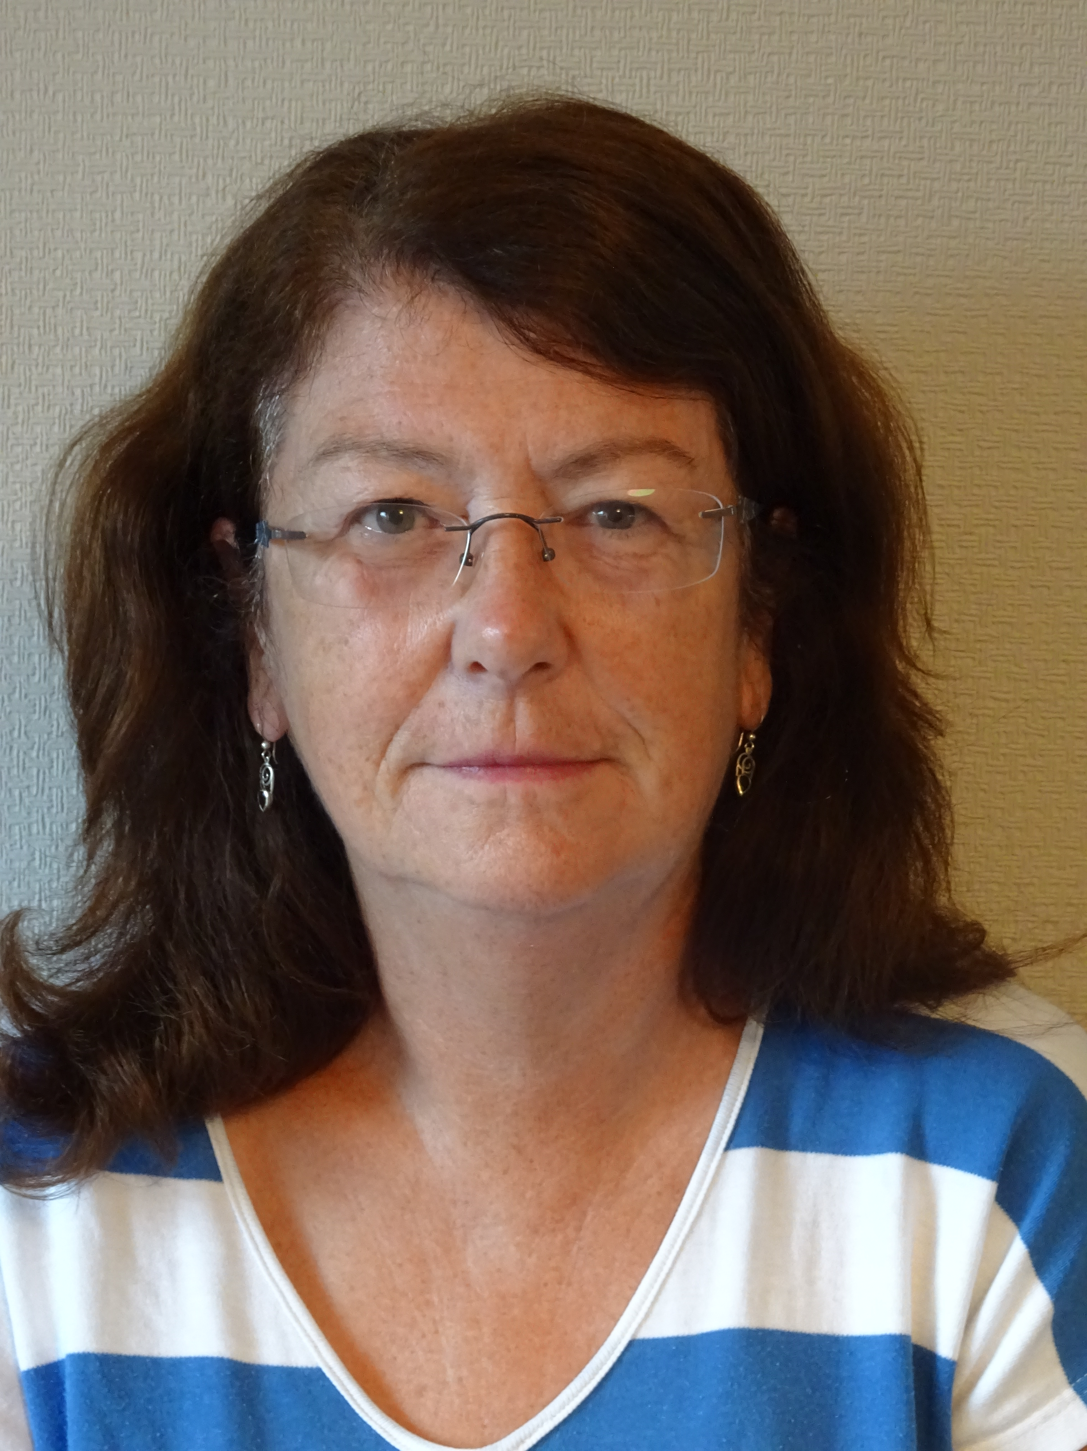](../../../AppData/Local/Microsoft/Windows/Temporary%20Internet%20Files/Pictures/2015-08-26/003.JPG)

Place Photo of Safeguarding

Officer here.

**CLUB**

**SAFEGUARDING OFFICER Motorsport-UK-Logo**